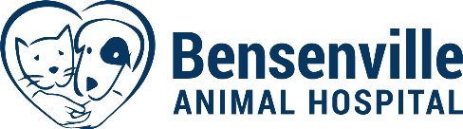
1208 W Irving Park Road
Bensenville, IL 60106
630-766-0620

Bath Consent Form

Client Name: _________________________________________ Date: ____________
Pet Name: ___________________________________________

Primary Contact Phone Number: ___________________________________

Alternative Contact Phone Number: _________________________________

Bath Includes: Bath, Brush, Blow Dry, Nail trim and ear cleanse.

Is there anything else you need done for your pet today? (Anal Glands $20)

Check preferred scent:

Cucumber Melon _____ Fresh ____ Blueberry Pie ____ Pineapple Coconut ____ None ____

Does your pet have any allergies or skin condition?

1. All pets admitted for bath services must be current on vaccinations. Written proof of vaccinations must be provided before any services can be provided to your pet(s). I consent that if vaccinations are overdue, they will be administered, and the cost will be added to the total bill.
2. All pets will be checked for parasites (fleas/ticks). If internal or external parasites are found by the veterinary staff while my pet is in for services, I consent to treatments as you determine, and the cost(s) of the treatment(s) will be added to my bill.
3. All precautions will be used to prevent injury/escape of my pet. Bensenville Animal Hospital and the team will not be held liable for any unforeseeable circumstances that may result in injury or death of my pet. If the need for emergency care arises, I give my permission for such care to be administered by Bensenville Animal Hospital.
4. I hereby give Bensenville Animal Hospital permission to take and use photographs and videos of my pet for the purpose of sharing on social media platforms.

Client Signature: _____________________________________ Date: ________________

Client Printed Name: _______________________________________________
Employee Initials: _________

