1208 W Irving Park Road
Bensenville, IL 60106
630-766-0620

Patient Drop Off & Consent Form

Client Name: _________________________________________ Date: ____________
Pet Name: ___________________________________________

Primary Contact Phone Number: ___________________________________

Alternative Contact Phone Number: _________________________________

What are we seeing your pet for today? ____________________________________________________________________________________________________________________________________________________________
- When was the last time your pet ate? _______________________ [ ] am [ ]pm
- What type of food and how much? __________________________________________

Please list any sensitivities or allergies to food, medication, vaccines, etc.
Allergen | Reaction | Last Occurrence

Please list any medications or supplements your pet currently on.
Name of Medication/Supplement | Amount Given | How Often | Last given  (Date and Time)

Please fill out the below history questions. Please provide as much detail regarding start/end of symptoms, when changes were noticed, details on the symptoms, etc. The more detailed the better.
- Any changes in pet’s food or water intake? If yes please explain below: ________________________________________________________________________________________________________________________________________________________________________________________________________________________
- Any changes in your pet’s activity level? If yes, please explain below: ________________________________________________________________________________________________________________________________________________________________________________________________________________________
- Any changes in pet’s urination or defecation habits? If yes, please explain below: ________________________________________________________________________________________________________________________________________________________________________________________________________________________
- Have you noticed any of the below? If yes, please explain below:

[ ] Coughing [ ] Sneezing [ ] Vomiting [ ] Diarrhea

________________________________________________________________________________________________________________________________________________________________________________________________________________________

- Does your pet receive at home dental care such as teeth brushing, dental chews or water additives? If yes, please list below: ________________________________________________________________________________________________________________________________________________________________________________________________________________________

- Have you noticed and new lumps, bumps, or growths or changes in existing lumps/bumps/growths? Please document their location on the chart below:

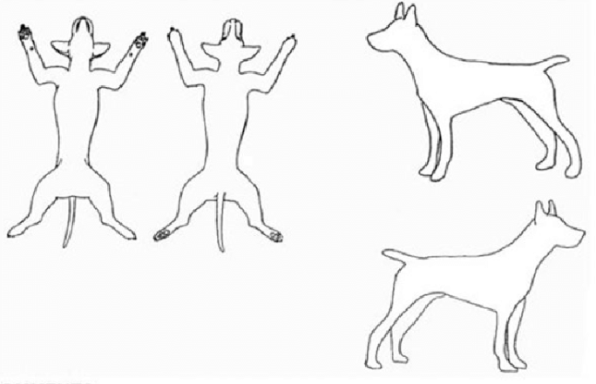
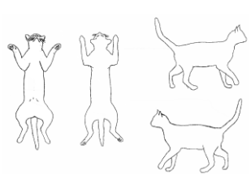
DOGS CATS

- Do you need any medication refills such as heartworm prevention, or flea and tick prevention? Please note refill requests below:

Name of Medication/Supplement

- Would you like any of the below performed while your pet is staying with us? (Additional costs apply)

[ ] Nail Trim [ ] Expression of Anal Glands [ ] Ear Cleaning [ ] Ear Plucking

- Please list any other questions or concerns that you would like to discuss with the doctor or have the doctor review. ________________________________________________________________________________________________________________________________________________________________________________________________________________________

Please read and initial

- We will call you as soon as your pet has been seen and treatment has been provided. The doctor or technician will call you prior to performing any additional diagnostic testing or treatment that the doctor believes may be needed.
Initials: _______
- We will strive to keep charges in line with any estimate given, however; unforeseen situations may arise. If the need arises, we will inform you of any additional charges that may be required prior to performing the service. If we cannot reach you, and a procedure needs to be performed for the health and safety of the animal, it will be done and charges will appear on your bill.

Initials: ________
- All pets that are admitted into the hospital are required to be current on all vaccinations, parasite checks and physical exams. All admitted pets must be free of external parasites. Animals with fleas or ticks present will be administered a preventative at the owner’s expense.
Initials: _________

- Pets that are hospitalized on an emergency basis will require a deposit for treatments based on an initial assessment. Extensive hospitalized stays may require keeping charges current prior to expected discharge.

Initials: _________

- All pets must be discharged prior to 5:15pm Monday-Friday and by 11am on Saturday to avoid a late discharge fee.

Initials: ________

- Payment for all rendered services is due at the time of discharge.

Initials: ________

- We at the Bensenville Animal Hospital do all we can to ensure that your pet received the safest and most up-to-date medical care. However, unforeseen complications can and do occasionally arise during or after a procedure. In the event of a complication, the attending veterinarian will proceed with treatments deemed necessary in their professional judgement until you can be reached. Any costs associated with emergency treatments are incurred at the owner’s expense.

Initials: ___________

I, the undersigned owner or agent of the owner, certify that I am eighteen years of age or over and authorize the veterinarian(s) at this practice to perform the above procedure(s). I understand that I am encouraged to discuss any concerns or questions about any medical risks with the doctor before any exam/procedure is/are initiated. I understand that medical treatments, including anesthesia, are not without risks. Your signature below signifies understanding of the above and authorizes the attending veterinarian to perform the procedures listed as well as any emergency treatment that may become necessary. Your signature also releases Bensenville Animal Hospital of any liability associated with the treatment of your pet both during and after service rendered.

Client Signature: _____________________________________ Date: ________________

Client Printed Name: _______________________________________________

Hospital Employee Initials: __________

