1208 W Irving Park Road
Bensenville, IL 60106
630-766-0620

Patient Drop Off & Consent Form - Surgery

Client Name: _________________________________________ Date: ____________
Pet Name: ___________________________________________

Primary Contact Phone Number: ___________________________________

Alternative Contact Phone Number: _________________________________

Please check any that may apply to your pet:

[ ] None [ ] Owner Protective [ ] Dislikes Other Animals [ ] Nervous/Shy [ ] Fearful

[ ] Aggressive (May Bite or Scratch) [ ] Kennel Reactive

What are we seeing your pet for today? ____________________________________________________________________________________________________________________________________________________________
- When was the last time your pet ate? _______________________ [ ] am [ ]pm
- What type of food and how much? __________________________________________

Please list any sensitivities or allergies to food, medication, vaccines, etc.
Allergen | Reaction | Last Occurrence

Please list any medications or supplements your pet currently on.
Name of Medication/Supplement | Amount Given | How Often | Last given  (Date and Time)
- If your pet is having a mass or masses removed or you would like to have the doctor look at an existing mass; please document their location(s) on the chart below:

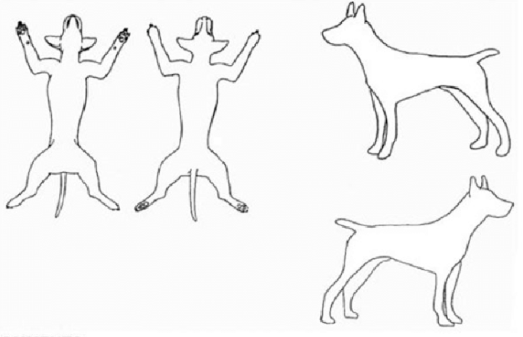
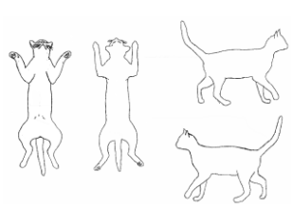
DOGS CATS

- Do you need any medication refills such as heartworm prevention, or flea and tick prevention? Please note refill requests below:

Name of Medication/Supplement

- Would you like any of the below performed while your pet is staying with us? (Additional costs apply)

[ ] Nail Trim [ ] Expression of Anal Glands [ ] Ear Cleaning [ ] Ear Hair Plucking

[ ] Other: ___________________________________________________________

- Please list any other questions or concerns that you would like to discuss with the doctor or have the doctor review. ________________________________________________________________________________________________________________________________________________________________________________________________________________________

Please read and initial below:

- We will call you as soon as your pet has been seen and treatment has been provided. The doctor or technician will call you prior to performing any additional diagnostic testing or treatment that the doctor believes may be needed.
Initials: _______
- We will strive to keep charges in line with any estimate given, however, unforeseen situations may arise. If the need arises, we will inform you of any additional charges that may be required prior to performing the service. If we cannot reach you, and a procedure needs to be performed for the health and safety of the animal, it will be done, and charges will appear on your bill.

Initials: ________
- All pets that are admitted into the hospital are required to be current on all vaccinations, parasite checks and physical exams. All admitted pets must be free of external parasites. Animals with fleas or ticks present will be administered a preventative at the owner’s expense.
Initials: _________

- Pets that are hospitalized on an emergency basis will require a deposit for treatments based on an initial assessment. Extensive hospitalized stays may require keeping charges current prior to expected discharge.

Initials: _________

- Payment for all rendered services is due at the time of discharge.

Initials: ________

- We at the Bensenville Animal Hospital do all we can to ensure that your pet receives the safest and most up-to-date medical care. However, unforeseen complications can and do occasionally arise during or after a procedure. In the event my pet experiences a cardiac, respiratory, or other life-threatening emergency that requires resuscitative or other urgent care measures, such as cardiopulmonary resuscitation (CPR), emergency drugs, or other similar measures, I request that the veterinarians and/or trained staff at Bensenville Animal Hospital pursue treatment as indicated below. Please initial one of the two options:

[ ] Resuscitate: I authorize emergency treatment if the situation arises (including cardio pulmonary resuscitation (CPR) and other life-saving treatments) and understand this may result in additional charges and I agree to pay for these emergency and life-stabilizing treatments even if they exceed any estimate I may have been provided. I understand that despite the best efforts of veterinarians and staff at Bensenville Animal Hospital, any emergency treatment does not guarantee or assure a favorable outcome for my pet.

[ ] Do Not Resuscitate (DNR): I do NOT authorize emergency treatment if the situation arises (including cardio pulmonary resuscitation (CPR) and other life-saving treatments) and prefer to be contacted before any additional treatment is performed. I understand that this may result in the death of my pet.

I, the undersigned owner or agent of the owner, certify that I am eighteen years of age or over and authorize the veterinarian(s) at this practice to perform the above procedure(s). I understand that I am encouraged to discuss any concerns or questions about any medical risks with the doctor before any exam/procedure is/are initiated. I understand that medical treatments, including anesthesia, are not without risks. Your signature below signifies understanding of the above and authorizes the attending veterinarian to perform the procedures listed as well as any emergency treatment that may become necessary. Your signature also releases Bensenville Animal Hospital of any liability associated with the treatment of your pet both during and after service rendered.

Client Signature: _____________________________________ Date: ________________

Client Printed Name: _______________________________________________

Hospital Employee Initials: __________

