
1208 W Irving Park Road
Bensenville, IL 60106
630-766-0620

Patient Drop Off & Consent Form - Surgery

Client Name: _________________________________________ Date: ____________
Pet Name: ___________________________________________

Primary Contact Phone Number: ___________________________________________________

In case of an emergency and I cannot be reached, please call: ______________________________________________________________________________

Please check any that may apply to your pet:

[ ] None [ ] Owner Protective [ ] Dislikes Other Animals [ ] Nervous/Shy [ ] Fearful

[ ] Aggressive (May Bite or Scratch) [ ] Kennel Reactive

Reason for visit/Surgical procedure? ____________________________________________________________________________________________________________________________________________________________

Would you like any other services performed while your pet is with us today?

[ ] Nail Trim [ ] Anal Gland Expression [ ] Ear Cleaning [ ] Ear Plucking [ ] Other: _____________________________________________________________________
Please list the Medications, dose and time of last dose received: _______________________________________________________________________________________________________________

Is your pet currently on any Medications?
- YES
- NO

When was the last time your pet ate and how much?

____________________________________________________________________________________________________________________________________________________________

Please list any sensitivities or allergies to food, medication, vaccines, etc.
Allergen | Reaction | Last Occurrence

If your pet is having a mass removal procedure, please document the location(s) on the chart below:

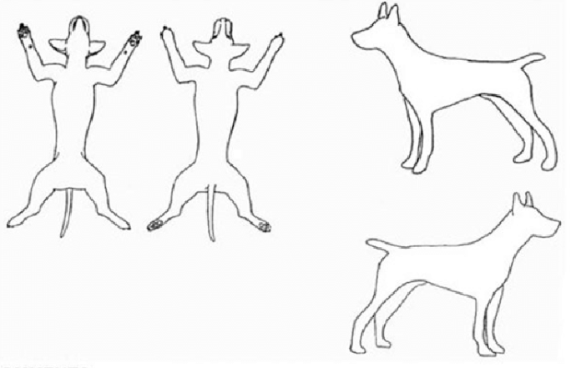
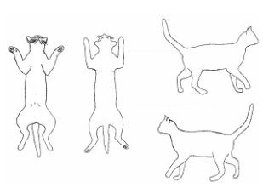
DOGS CATS

Please read and initial below:
· We will call you as soon as your pet has been seen and treatment has been provided. The doctor or technician will call you prior to performing any additional diagnostic testing or treatment that the doctor believes may be needed.
Initials: _______
· We will honor to keep charges in line with any estimate given. However, unforeseen situations may arise. If the need arises, we will call to inform you of any additional charges that may be required prior to performing the service. If we cannot reach you, and a procedure needs to be performed for the health and safety of the animal, it will be done, and charges will appear on your bill. Pets that are hospitalized on an emergency basis will require a deposit for treatments based on an initial assessment. Extensive hospitalized stays may require keeping charges current prior to expected discharge. Payment for all the services rendered is due at the time of discharge.
Initials: _______
· All pets that are admitted into the hospital are required to be current on all vaccinations; parasite checks and physical exams prior to a surgical procedure. All admitted pets must be free of external parasites. Animals with fleas or ticks present will be administered a preventative at the owner’s expense.
Initials: _______

We at the Bensenville Animal Hospital strive to ensure that your pet receives the safest and most up-to-date medical care. However, unforeseen complications can and do occasionally arise during or after a procedure. In the event my pet experiences a cardiac, respiratory, or other life-threatening emergency that requires resuscitative or other urgent care measures, such as cardiopulmonary resuscitation (CPR), emergency drugs, or other similar measures, I request that the veterinarians and/or trained staff at Bensenville Animal Hospital pursue treatment as indicated below.
Please initial one of the two options:
[ ] Resuscitate: I authorize emergency treatment if the situation arises (including cardiopulmonary resuscitation (CPR) and other life-saving treatments) and understand this may result in additional charges and I agree to pay for these emergency and life-stabilizing treatments even if they exceed any estimate I may have been provided. I understand that despite the best efforts of veterinarians and staff at Bensenville Animal Hospital, any emergency treatment does not guarantee or assure a favorable outcome for my pet.
[ ] Do Not Resuscitate (DNR): I do NOT authorize emergency treatment if the situation arises (including cardiopulmonary resuscitation (CPR) and other life-saving treatments) and prefer to be contacted before any additional treatment is performed. I understand that this may result in the death of my pet.
I, the undersigned owner or agent of the owner, certify that I am eighteen years of age or over and authorize the veterinarian(s) at this practice to perform the above procedure(s). I understand that I am encouraged to discuss any concerns or questions about any medical risks with the doctor before any exam/procedure is initiated. I understand that medical treatments, including anesthesia, are not without risks. Your signature below signifies understanding of the above and authorizes the attending veterinarian to perform the procedures listed as well as any emergency treatment that may become necessary. Your signature also releases Bensenville Animal Hospital of any liability associated with the treatment of your pet both during and after service rendered.
I understand that if my pet requires overnight round-the-clock specialty or emergency care, I may be referred to a 24-hour emergency veterinary hospital and my pet will require owner-provided transportation prior to the end of day at Bensenville Animal Hospital.
Client Signature: ___________________________________________ Date: ________________
Client Printed Name: ____________________________________________________________
Hospital Employee Initials: __________

